Communication preferences

Template

Step 1:

1. In the first column, from the list of behaviors below, please choose the top 7 that most resonate with you, by marking a tick ✓ next to it.
2. On the second column, from the 7 behaviors that you have ticked, now select your top 5 and rank them from most like you (1) to least like you (5).

|  |  |  |
| --- | --- | --- |
| Behavior | My top 7 ✓ | Rank your top 5  *(1 = most like you; 5 = least like you)* |
| Likes challenges | ✓ | 1 |
| Results focused | ✓ | 3 |
| Competitive | ✓ | 2 |
| Determined |  |  |
| Assertive |  |  |
| Decisive |  |  |
| Risk Taker |  |  |
| Sensitive to others |  |  |
| Sociable |  |  |
| Emotional |  |  |
| Stimulating |  |  |
| Outgoing |  |  |
| Optimistic |  |  |
| Enthusiastic | ✓ | 4 |
| Tactful |  |  |
| Calm |  |  |
| Patient | ✓ | 6 |
| Dependable |  |  |
| Supportive | ✓ | 5 |
| Accommodating |  |  |
| Procedure orientated |      ✓ | 7 |
| Precise |  |  |
| Private |  |  |
| Systematic |  |  |
| Restrained |  |  |
| Likes numbers |  |  |
| Perfectionist |  |  |
| Critical of mistakes |  |  |

Step 2:

Now please complete your research. Here is a reminder of DiSC. The example behaviors are drawn from the previous table.

Introducing the DiSC model

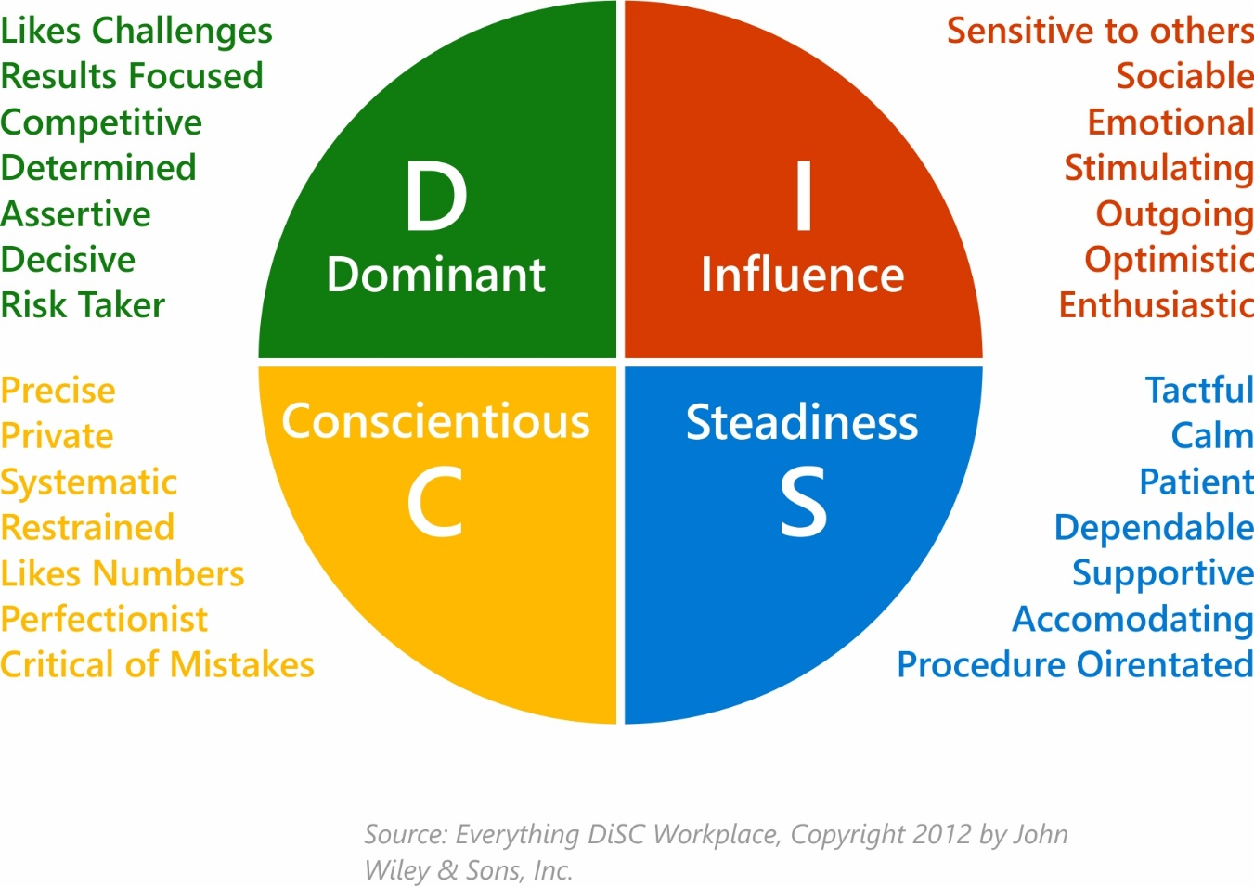

Step 3:

Following your research, answer the final 2 questions below.

1. What have you learned about yourself from the DiSC model?

I am dominant and Steadiness behavior in me.

1. What have you learned about DiSC and its value when communicating with others?

One of the most powerful tools you can employ to build your professional sales relationships and success. These comprehensive assessments and analytic tools provide valuable insights into individual behaviors and underlying motivators to help you: